Week-10
- Install and configure Jenkins:
Jenkins is primarily used for continuous integration and continuous delivery on a platform. It is a Java application that has multiple plugins for automating all components at an infrastructure level.
Requirements to Install Jenkins on Windows
- Operating System: Windows
- JDK Version: JDK 8 – Java SE
- Memory: 2 GB
- Disk space: 500MB.

Step1: Go to browser and search for JDK 17, click on JDK download for java download JDK 17, open the link and under Java SE Development Kit 17.0.15.1 select windows *64 installer.
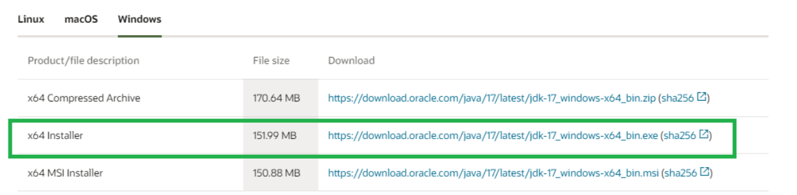

Step2: Accept the agreement and click on download. And run the Setup file.

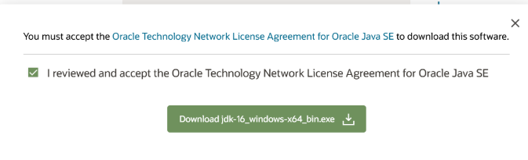

Step3: Click on next.

Step4: You can there path or you can click on next.

Step5: Wait until installation is complete.

Step6: Set the path for the environmental Variable for Jdk.

Go to Control Panel, under that select System Properties in that at right corner select advanced Setting option.
• In Advanced Setting option select “Environment Variable”.
• Under “system Variable”, Select New then copy the path of the jdk folder Bin path and paste it.
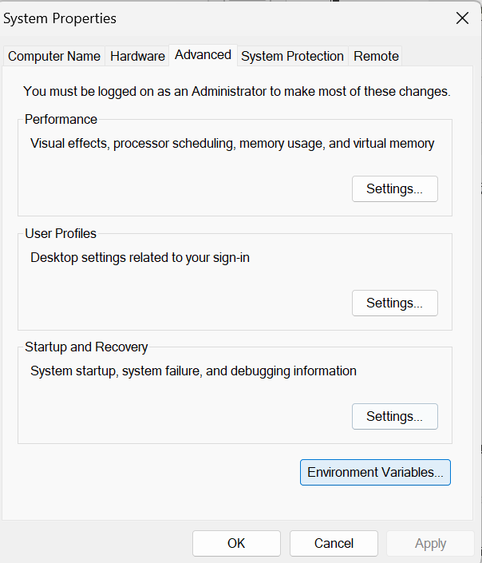
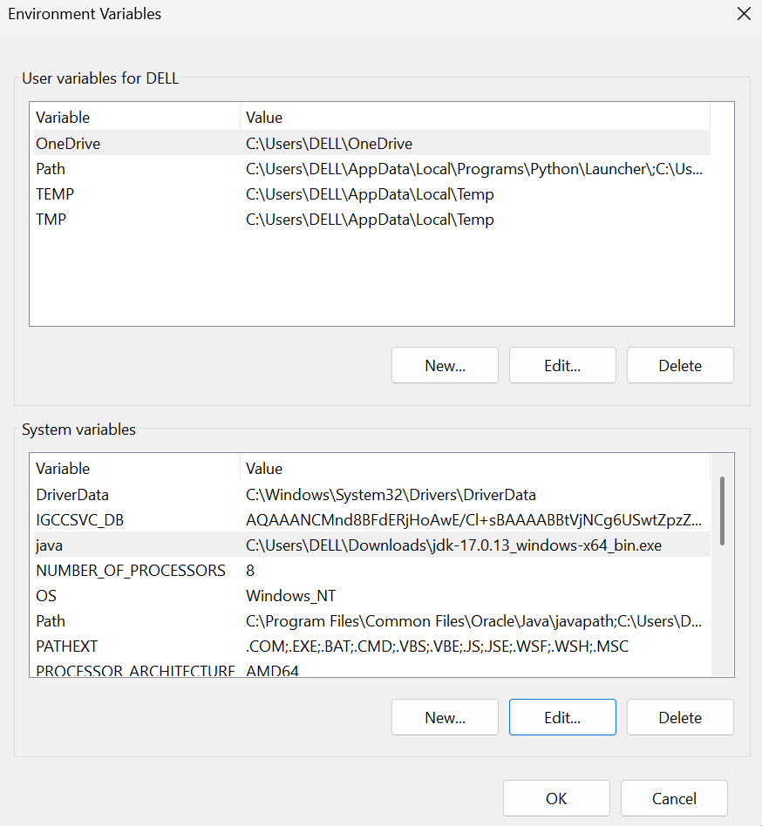

To test whether the Jdk17 are working or not go to Command prompt and type the following command to check or test the Jdk17 has been Successfully installed.
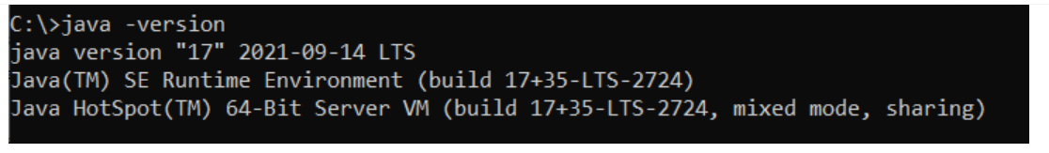

Installation of Jenkins Steps :
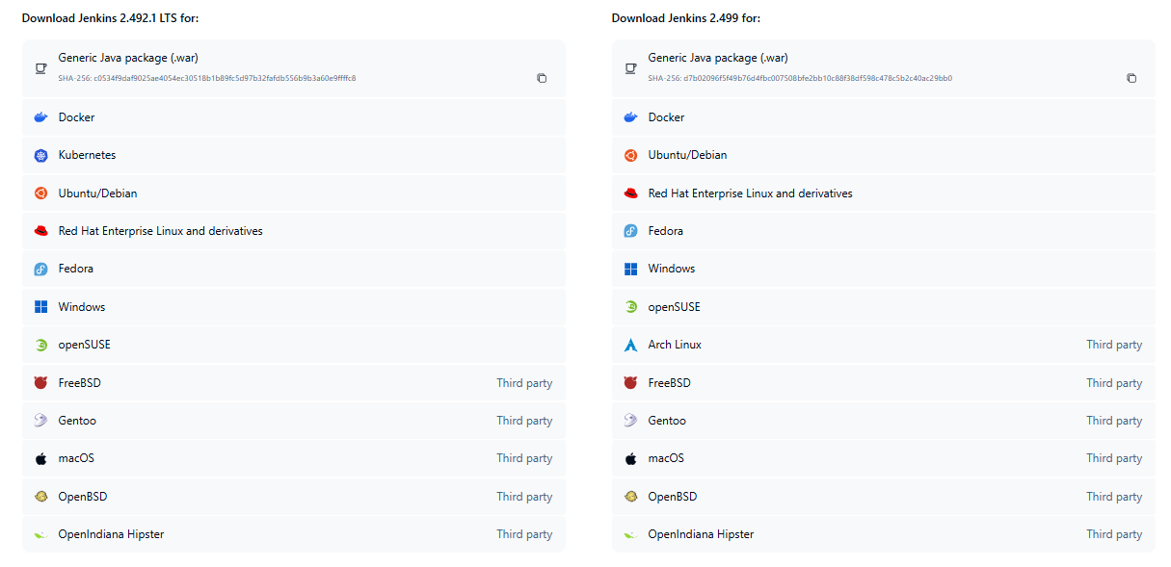
Step1: Go to Web Browser and Search for Jenkins and download it.

Step2: Once the download is Complete, run the Jenkins.msi installation file.
The Setup Wizard Starts and Click Next.

Step3: Select the install destination folder and click Next to Continue.

Step4: Select the run service as Local System, and click next.

Step5: Enter the port number you want Jenkins to run.
For Ex: my port number is 8080
Click test port to check if the selected port is available then click on Continue.
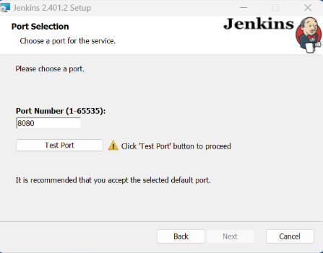

Step7: Click on JDK 17 and click on Next.

Step8: Click on Next

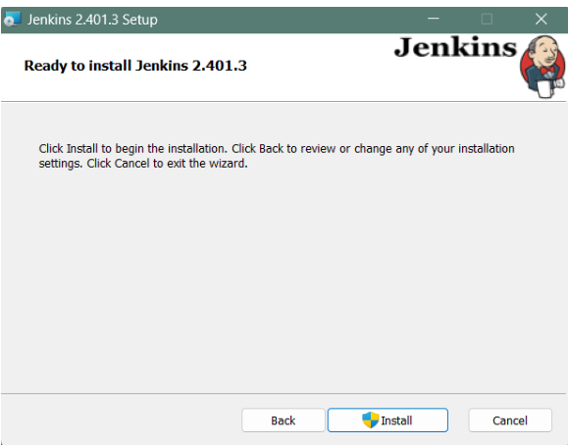
Step9: Select Install.

Step10: Once it installed Complete click on finish.
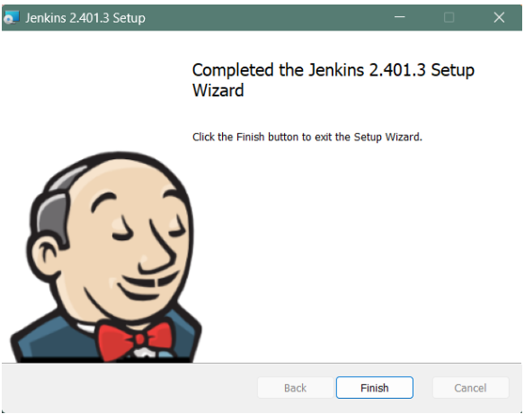

Unlocking Jenkins
When you first access a new Jenkins controller, you are asked to unlock it using an automatically-generated password.
Step 1: Browse to http://localhost:8080 (or whichever port you configured for Jenkins when installing it) and wait until the Unlock Jenkins page appears.
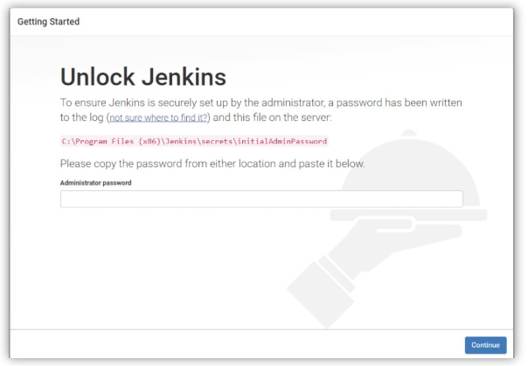

How to Configure Jenkins
Step1: Install Plugins.
● Jenkins is composed of multiple components called plug-in. The next step it asked for which plugins you would like to install then just install the Suggested plug-in.

- Wait until download is completed.

Step2: Create a Jenkins User.
The next step is to create a Jenkins admin user. Make Sure you write down the user name and the password as you will need them later.

Step3: Configure the Jenkins URL. The final step is to configure the URL for Jenkins server. This would be pre-filled for you. So all you need to do is to click “save and continue”.

Step4: Click on Start using Jenkins.
Soon the Server will be configured and ready for Action

- Create a container image for Hello world project
Step1: After Logging in to the Jenkins Click on the “new item” menu option.

Step2: Type in the name of the Jenkins pipeline & Click on the “pipeline”.

Step3: Then press the “OK” button.

Step5: Scroll down to the section called “pipeline”, paste the following code, in try Sample project, Select Hello World.

Step6: Click Save the project & to run this select click on build now.

- Setup build for Container image using Jenkins (Hello world application)
Step1: Go to build History right click on last build and select console output.

Step2: The Hello world application successfully.
Console output:

